Kurt Leadley

Wendy Portillo

Karie Funk

Professor Krasso

Web-330-Group-C

August 23rd, 2019

Prototype

**Karie Proposal 1 :**

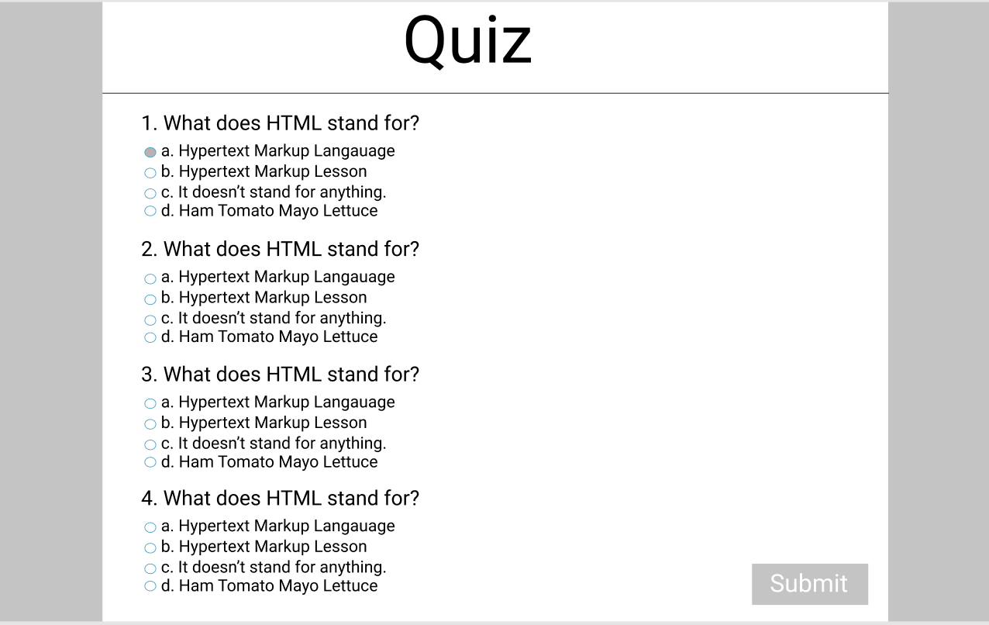

**Kurt’s Response:** It is intuitive, but nothing really stands out with this design. Other than that, there is nothing really wrong with this design, as long as that submit button isn’t seen until after question 10. We don’t want the user to submit a half done quiz. I don’t think that was your plan anyways though. This is a 4 question quiz : )

**Wendy Response:**

I like that it is simple layout Karie. The users taking the test won’t feel so overwhelmed with the layout design. As far as creating a single page design, I agree with Kurt. It would contribute the users to an intuitive journey. With no additional pages, users can enjoy a linear navigation flow, which would tell them when they are done with the test. They do not have to guess if its the beginning, middle, or end.

**Karie Proposal 2:**

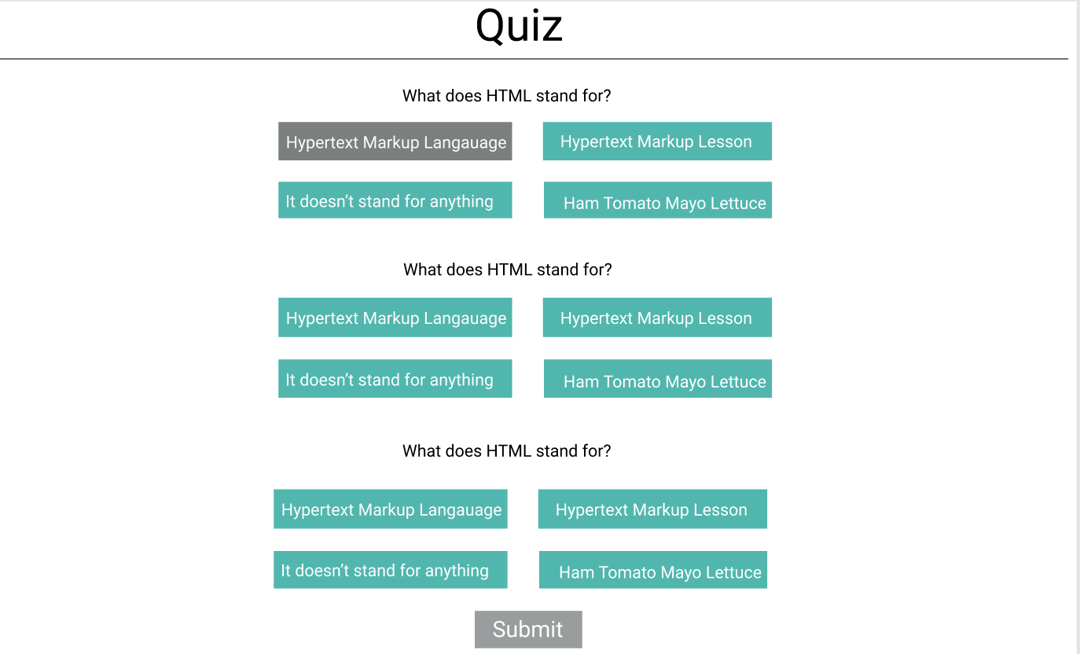

**Kurt’s Response**: I like this one a lot and think we should go with this design. This is what I see a lot in many designs. It looks nice and is intuitive. We just have to make sure that the user is aware if he somehow clicks over another answer on accident.

**Wendy’s Response:** Following the simple layout. I like the aesthetic of this layout. Incorporating the answers in a block is simple, sharp, and decent looking webpage. The color scheme looks fresh and not overdone.

**Wendy Proposal 1 :**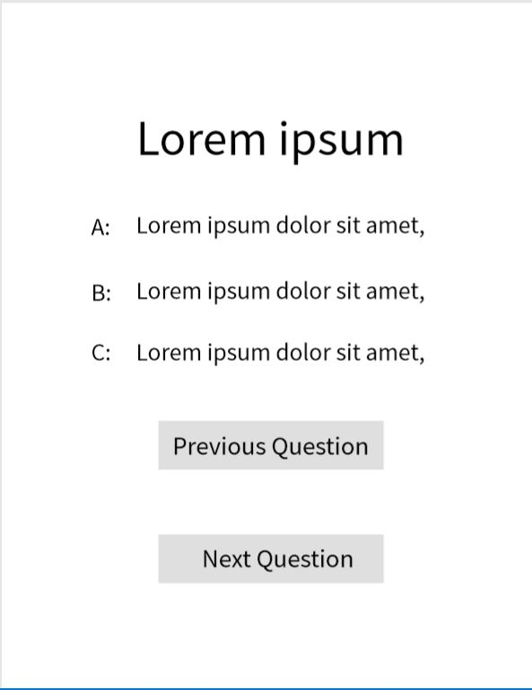

**Kurt’s Response:** I initially liked the idea of having a next and previous question feature to our quiz. After thinking about it for a while though, I realized that I prefer to just scroll up and down when answering questions. Also, we are supposed to make a single page application, so if we were to do this sort of thing, we would have to hide / unhide divs on just about every onclick event. It could get over complicated on a development side for a feature that the user might not even like in the first place.

**Karie’s Response:**

I like the idea of having buttons that say previous question and next question! This is a simple way of doing this, but I like it. However, I don’t think this will work as a single application though. I am thinking we should go with having several questions on one page, instead of just having one and switching to another page.

**Wendy Proposal 2 :**

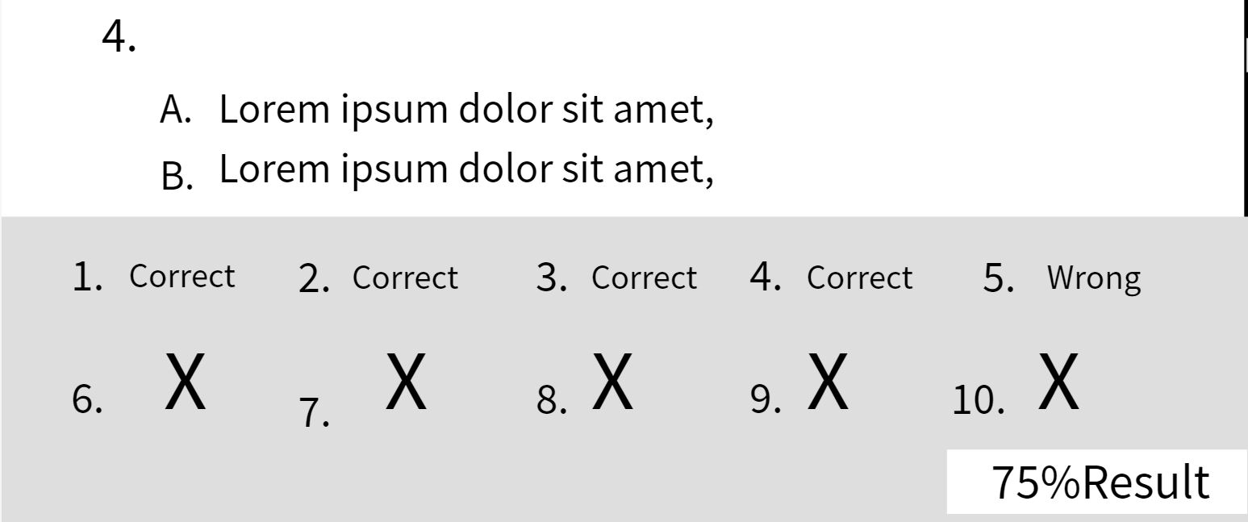

**Karie’s Response:**

I also agree with Kurt’s response on this. I like this enough to think that we should incorporate it into our project somehow. I know I like being able to see which one’s I got right and wrong after taking a quiz instead of just seeing the percentage and that’s it.

**Kurt’s Response:** This isn’t the entire design from this 2nd prototype from Wendy, but this is the part I wanted to focus on. The entire prototype can be seen in our shared folder. I think we should implement this sort of scoreboard on the results page. I like it. Without scrolling, you know your score and what questions you got wrong and right. One thing to watch out for though, is you can’t show these stats while the user is taking the test. Showing a right or wrong tally means that the user should not be able to change an answer, when I think they should be. This type of display should be only available after final submission.

With this, and one of Karie’s prototypes, I have made my own proposition below.

**Kurt’s Proposal:**

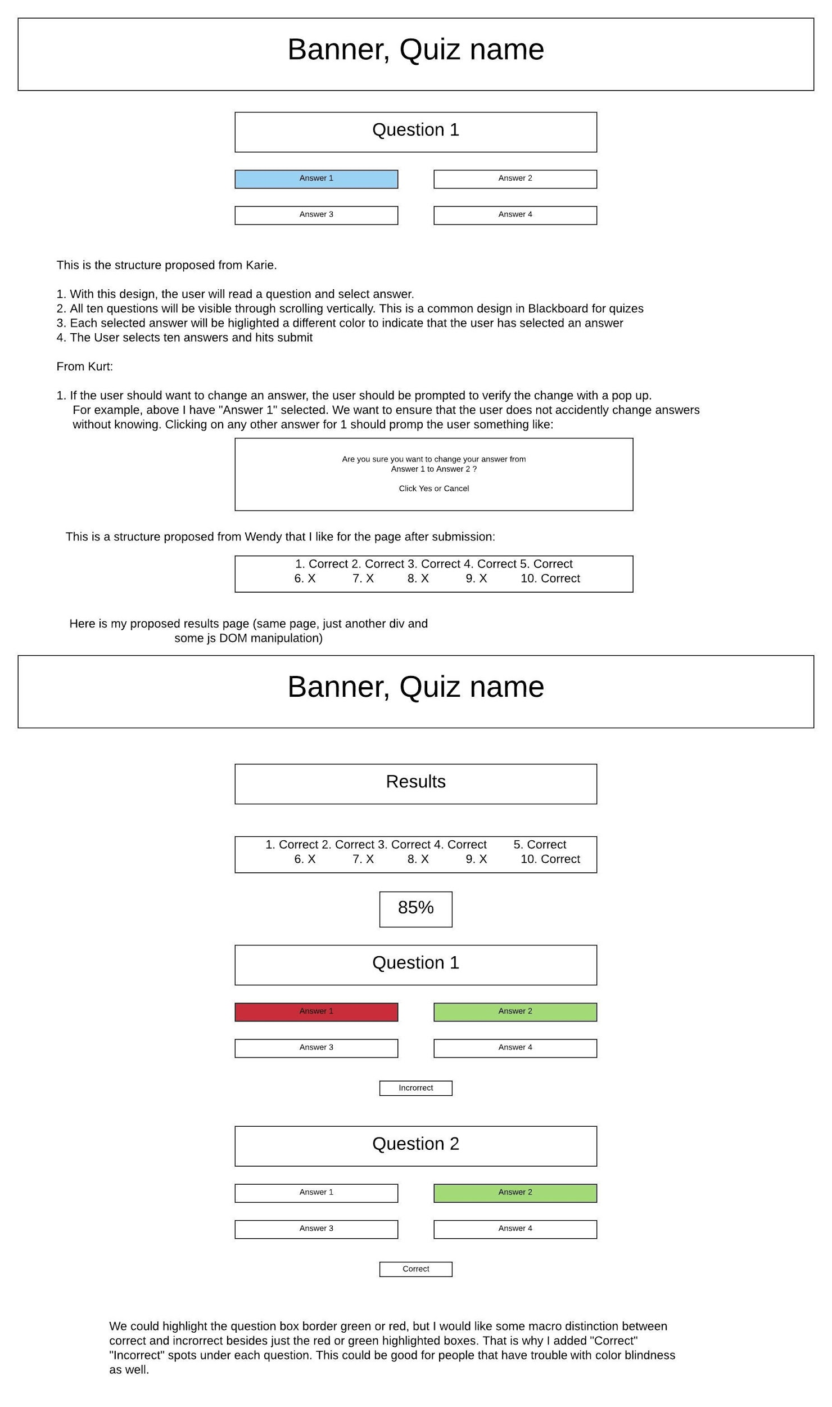

The box with the 10 correct / incorrect answers will obviously be lined up with the final product, the software I was using was giving me a hard time : )

**Wendy’s Response:**

I liked the clearly marked, distinct navigation labels at the top of your home page with results and break-down of the questions Correct/Incorrect. Keeping the main navigation simple and the top of your page where the users can find the information they need. I also like your approach to evoke an emotional reaction with the color scheme using red and green. It works great with this website’s allowing the users to see which questions are correct/incorrect.

**Karie’s Response:**

Great job Kurt! I like this design and think we should go with it. I also like the color scheme being used with the correct/incorrect answers.

**For Professor Krasso: We will be using the prototype named “Kurt’s Proposal”. This is a combination of all 3 of our ideas into one prototype.**

Links to full documents and PDF’s here:

<https://drive.google.com/drive/u/0/folders/1Azs9BL2N9N9WQER-QwAZLSu8KV8Nd5yr>